SQL Query to create table eventplan :

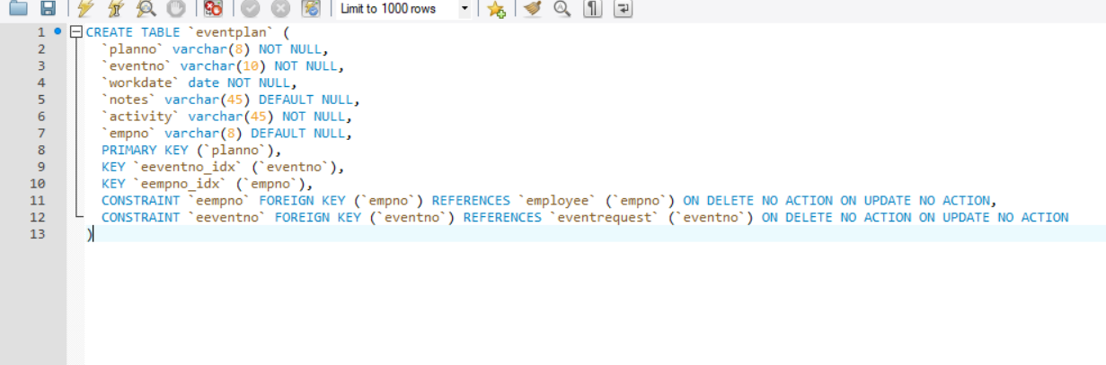

Eventplan table :

